“Hot Wire Anemometer”

**It is the project of final year**

* **Probe selection**

Probes are primarily selected on basis of:

* Fluid medium
* Number of velocity components to be measured (1-, 2- or 3)
* Expected velocity range
* Quantity to be measured (velocity, wall shear stress etc.)
* Required spatial resolution
* Turbulence intensity and fluctuation frequency in the flow
* Temperature variations
* Contamination risk
* Available space around the measuring point (free flow, boundary layer flows, confined flows).
* Quick guide to probe selection

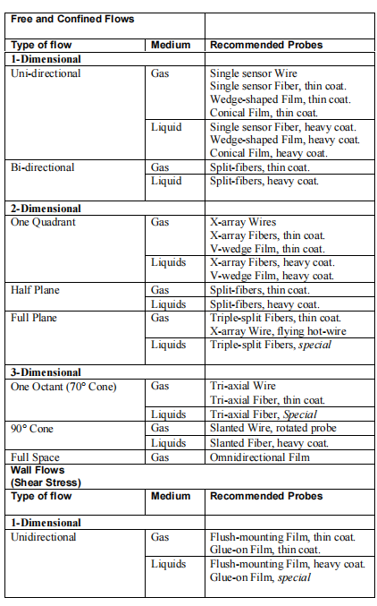

* Sensor types:

Anemometer probes are available with four types of sensors:

* Miniature wires,
* Gold-plated wires,
* Fibre-film or Film-sensors.
* Miniature wires:

Wires are normally 5 µm in diameter and 1.2 mm long suspended between two needle-shaped prongs

* Gold-plated wires:

Gold-plated wires have the same active length but are copper- and gold-plated at the ends to a total length of 3 mm long in order to minimise prong interference.

* Fibre-film or Film-sensors:

Fibre-sensors are quartz-fibers, normally 70 µm in diameter and with 1.2 mm active length, covered by a nickel thin-film, which again is protected by a quartz coating.

* Film-sensors:

Film sensors consist of nickel thin-films deposited on the tip of aerodynamically shaped bodies, wedges or cones.

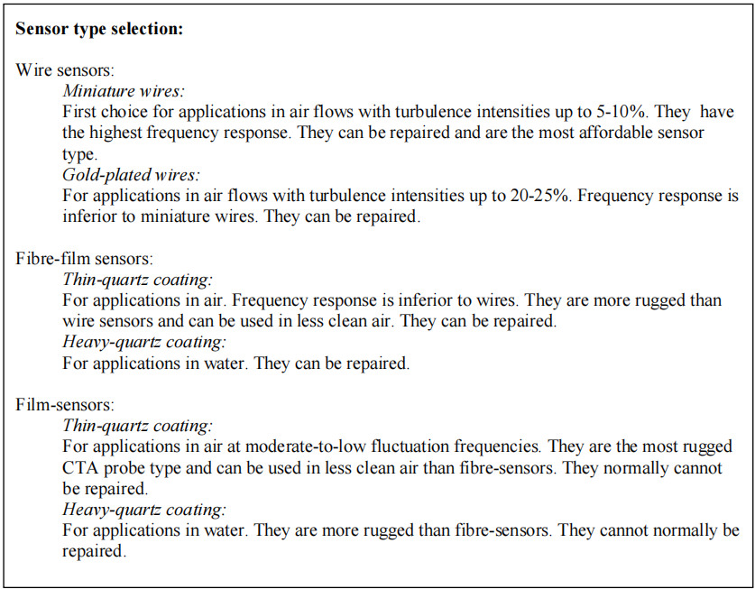

* **Note:** *Wire probes and fibre-film probes with thin quartz coating can be used in non-conducting liquids.*